A000-Asia-China- Liangzhu-Jade- Three-Post -3400–2250 BCE

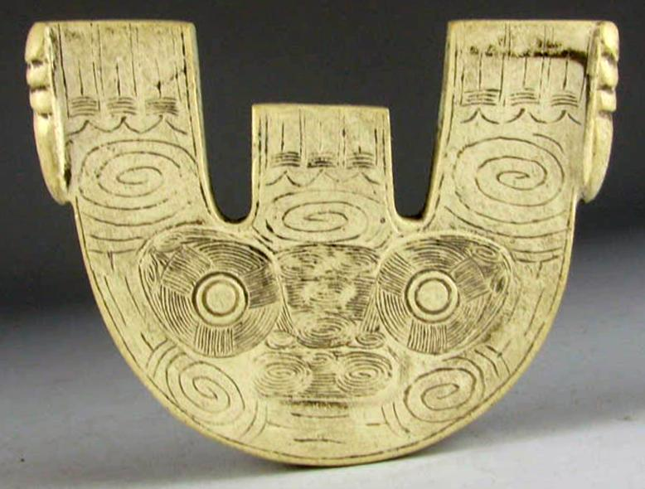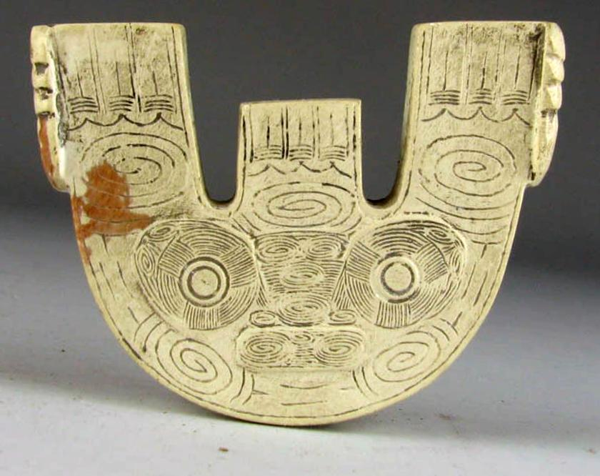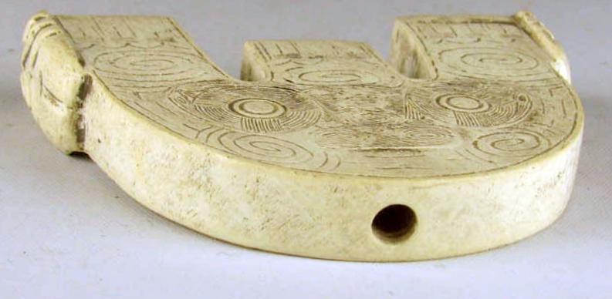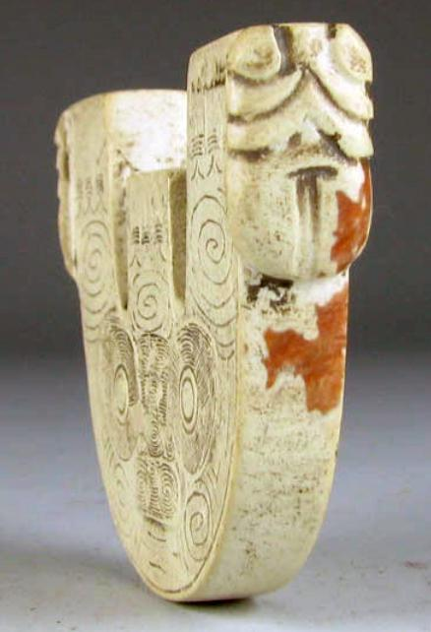

Figs. 1-4. Liangzhu-Jade- Three-Post -3400–2250 BCE.

Fig. 1. 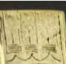 Showing Rain Clouds as a descending curtain, combined with 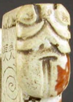 the end view Fig. 4. showing the Dragon-Alligator (*Alligator sinesnsis*), the sign of impending rain as signified by the Rain Cloud Curtains. This clearly implies the rôle of the Shaman in predicting when the rains will come.

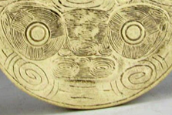 The Shamanic Mask is bracketed by a Clockwise spiral indicating the normal motion of the Pole Star and a Counter-clockwise spiral signifying the problem of retrograde motion seen in the Heavens and the esoteric rôle of the Shaman as a Liangzhu Astronomer charged with interpreting both phenomena.

Fig. 4: End view of the Three-Post showing the Dragon-Alligator (*Alligator sinesnsis*), the sign of impending rain as signified by the Rain Cloud Curtains above.

Case: 5

**Accession Number:**

**Formal Label:** Liangzhu-Jade- Three-Post -3400–2250 BCE

**Display Description:**

This Jade Three-Post was used by shamans participating in astronomical rituals honoring numinous Heaven and the circulation of Earth around the immovable Pole Star. The motifs carved into the Three-Post include dragon-alligators (*alligator sinensis*) at both termini, a symbolic reptile that presages the coming of rain and the fructification of crops.

The Motion of Earth (Dìqiú de yùndòng, 地球的運動) around the Pole Star (Jí xīng, 極星) is indicated by the spirals suggesting Heavenly Motion. In addition, the incorporation of Jade Staves were added to this platform to complete the symbolic thrust of the ceremony, linking the Shamanic Powers and the Heavenly Powers that was lacking in the Jade Three Post.

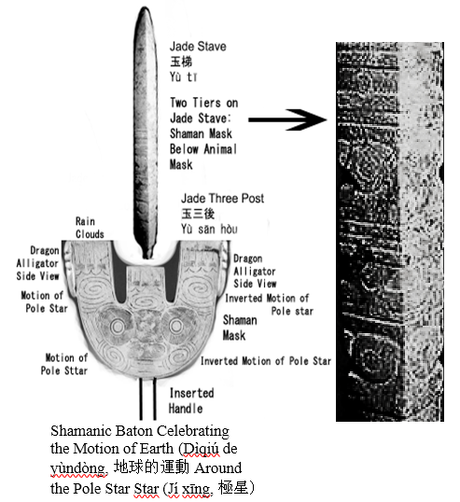

This shamanic baton Shamanic Baton Celebrating the Motion of Earth (Dìqiú de yùndòng, 地球的運動around the Pole Star Star (Jí xīng, 極星) parallels the evolution of the masks on congs that initially combined an animal mask *below* that of a human mask to comprise a single-tier Human/Animal Mask Motif. This clearly emphasizes the rôle of the Shaman *above* the Animal, i.e., Heavenly Knowledge *above* Earthly knowledge. From the point-of-view of shamanism this suggests that the shaman’s psychological integration with the animal was subordinate to a more rationalistic rôle and helps conceptualize the evolution from shamanism to that of shaman-astronomer.

Towards the end of the Liangzhu Period (2800-2250 BCE) the animal mask was eliminated from Liangzhu iconography and with it went the shamanic psychological referent. The human mask alone on congs of that period may have symbolized only an historical referent, the succession of ancestors. If this is correct, then this ritual implement combining both the Jade Stave ad the Jade Three-Post probably dates to the early Liangzhu Period ca 3400-2800 BCE, before shamanic symbolism was curtailed from Liangzhu iconography and ancestor worship took precedence in Late Liangzhu rituals. If this is correct, the this may help document the rise of the Liangzhu élites as they acquired more power in society.

**LC Classification:** NK5750.2.A1

**Date or Time Horizon:** Liangzhu-Jade-Headdress-Three Post Holder-3400–2250 BCE BCE **Geographical Area:** Liangzhu culture, lower Yangzi River Valley

**Map:**

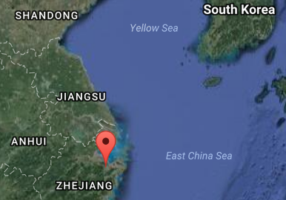

Fig. 5. Location of Liangzhu site proper. Source: Google Earth

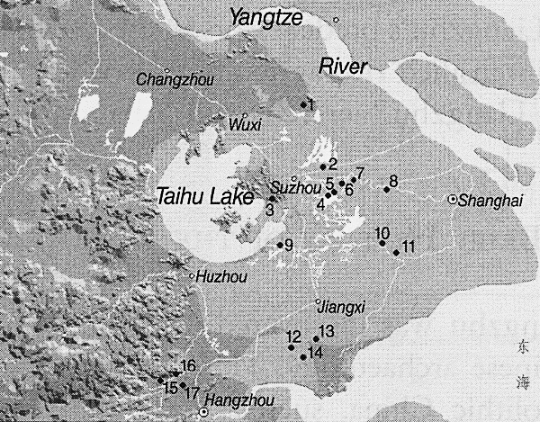

Fig. 6. Detail of Liangzhu site complex surrounding Taihu Lake. After Zhou Ying 2007.

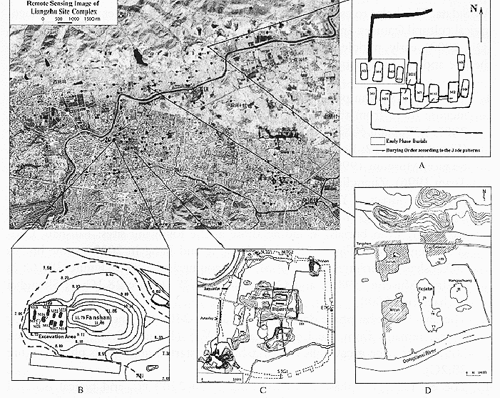

**Fig. 7.** Detail of Liangzhu site complex (A, C, D) and Liangzhu site proper (B). After Zhou Ying 2007.

**GPS coordinates of Fig. 7 B:**

Northeast corner: N 30°24'48", E 120°00'17"

Northwest corner: N 30°24'41", E 119°58'58"

Southeast corner: N 30°23'20", E 120 00'19"

Southwest corner: N 30°22'55", E 119°58'28"

GPS Coordinate on Map as approximate average: N 30°24', E 120 00'

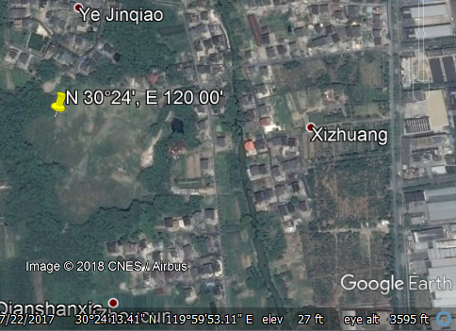

Fig. 8 Liangzhu site proper (Fig. 7B). After Google Earth.

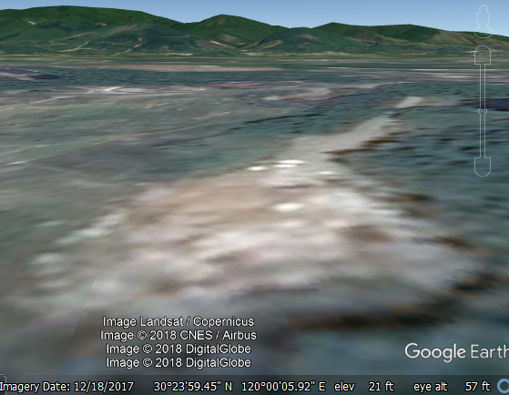

Fig. 9 Liangzhu site proper (Fig. 7B) and mountains in background. After Google earth, ground view.

**Cultural Affiliation:** Liangzhu culture, lower Yangzi River Valley, 3300-2250 BCE

**Medium:** jade

**Dimensions:** H 2 in, W 2.0 in, thickness 0.3 in.

**Weight:**

**Condition: original. The reddish stain** is thought to have been produced by minerals leaching from the decaying body into the nephrite during burial, a process that occurs in the first weeks after interment.

**Provenance:**

**Discussion:**

Liangzhu (3400–2250 BCE) in Yuhang County, Zhejiang, became a highly stratified society in the latter Liangzhu Period ca 2800-2250 BCE when élites began to control a sphere of influence that extended north to Shanxi and south to Guangdong. Jade and other expensive wares (such as silk, lacquerware, and ivory) characterized the social symbolism of Liangzhu élites which they used in ritual performances and dances as well as in grave goods. In this period the previous rôle of the shaman was curtailed in its psychological component and elevated in its rational component as astronomer.

DNA from Liangzhu culture sites around Taihu Lake the Yangtze River exhibit high frequencies of Haplogroup O1 which was absent in other archaeological sites that were sampled inland of the Liangzhu complex. Haplogroup O1 is common to modern Austronesians and Taiwanese Aborigines/Taiwanese Austronesians (TAN) (O1) probably came from those Liangzhu Austronesians (LAN) who had been displaced from the mouth of the Yangtze River delta by an economic crash of the LAN ca 4500 BCE induced by a meteor that struck at the present location of Taihu Lake, a meteoric crater. LAN culture sites that existed around Taihu Lake and the mouth of the Yangtze River succumbed by ca 4200 BP LAN to a series extreme floods from diversions of the Yangtze River that interrupted the cultural layers with intrusions of mud and sand. It took 800 years, from 4200 BCE until 3400 BCE, for the Liangzhu culture on the mainland to recover. At the end of this time-horizon, Taiwanese migrants began to sail east to the Buka Strait in the Solomon Islands which became a staging area for the populating of Polynesia ca 2500 BCE.

**References:**

Biot, Jean Baptiste. 1851. *Le Tcheou-li: ou, Rites des Tcheou*. Paris: Imprimerie nationale, 1851. 3v.

Chang, K.C., Xu, P. and Lu, L. 2005. *The formation of Chinese civilization: an archaeological perspective*. New Haven: Yale University Press.

Childs-Johnson, Elizabeth. 1988. *Ritual and Power: Jades of Ancient China*. New York: China House Gallery, China Institute in America.

Childs-Johnson, Elizabeth. 2009. “The Art of working Jade and the rise of civilization in China.” In Elizabeth Childs-Johnson, *Early Chinese jades in American Museums.* Beijing: The Science Press, China Science and Technology Publishing and Media Co., Ltd., 2009, pp. 291-393.

Gu Fang. 2005. *Complete collection of unearthed jades in China*. 15 v. Beijing: China Science and Technology Publishing and Media Co., Ltd.

Hayashi, Minao. 林巳奈夫. 1991. *Chūgoku kogyoku no kenkyū*. 中國古玉の研究. Tōkyō : Yoshikawa Kōbunkan; 東京 : 吉川弘文館, 1991.



Hayashi, Mineo. 1990. “On the Chinese Neolithic jade Tsung/Cong,” *Artibus Asiae*, 50(1/2):5-22.

Hayashi, Mineo. 1973. *Toyo Gakuho* [Journal of the Research Dept. of the Toyo Bunko] 45:1-57.

Laufer, Berthold. 1912. *Jade a study in Chinese archaeology and religion*. Field Museum of Natural History, Publication 154, Anthroplogical series, vol. X. Chicago.

Li, Hui; Huang, Ying; Mustavich, Laura F.; Zhang, Fan; Tan, Jing-Ze; Wang, ling-E; Qian, Ji; Gao, Meng-He; Jin, Li. 2007. "Y chromosomes of prehistoric people along the Yangtze River," Human Genetics **122**: 383–388.

Lu Wenbao. 1998. Cong-shaped bead. In Liangzhu Culture Museum, ed., The dawn of Chinese civilization: Jades of the Liangzhu culture. Hong Kong: Liangzhu Culture Museum and The Art Museum, The Chinese University of Hong Kong.

Wu, Li. 2014. "Holocene environmental change and its impacts on human settlement in the Shanghai Area, East China," Catena. **114**: 78–89

Zhang, Chia; Hsiao-Chun, Hung. 2008. "The Neolithic of Southern China–Origin, Development, and Dispersal,"Asian Perspectives. **47**:2, 309–310.

|  |
| --- |
| Zhou Ying. 2007. 东方文明的曙光: 良渚遗址与良渚文化 = **Dong fang wen ming de shu guang : Liang zhu yi zhi yu liang zhu wen hua =** *The Dawn of the Oriental Civilization: Liangzhu site and Liangzhu culture*. Beijing: China Intercontinental Press. |